**OnFest**

**Project Plan v2**

Date: 25 Februari 2018

Course: ProP

Group: 31

Dimitar Parpulov - 3207358

Diqin Yang - 3324087

Dongdong Ke - 3338207

Phat Tran - 3335968

**Table of Contents**

***Chapter 1***

Project Statement[2](https://docs.google.com/document/d/1VxJA-1bs_ad3mZtRtJoP_YYw6ASzNP4EmwSPoIONI1k/edit#heading=h.gjdgxs)

Formal Client 2

Project Leader 2

Current Situation 3

Problem Description 3

Project Goal 3

Project Deliverables and Non-Deliverables 3

Project Constraints 4

Project Risks 4

***Chapter 2***

[Project Phasing](https://docs.google.com/document/d/1MTbcWzN2N5sH5wan6hqOxl8rTX1kvQTQIBtjn1HV81A/edit#heading=h.tp9znly8nmzw) 5

Phase 1: Initiation 5

Phase 2: Design 7

Phase 3: Building and developing 7

Phase 4: Testing 8

Phase 5: Finalizing 8

# 

# **Revision History**

|  |  |  |  |
| --- | --- | --- | --- |
| Version | Date | Summary of changes | Revision |
| 1 | 25-02-2018 | Added all sections, cover of the document, filling the information for each section; | Initial document |
| 2 | 02-03-2018 | Added more risks, constraints, more specific phasing | Second version |

# 

# **Project Statement**

In this document, we will describe why our project is initiated and what we will accomplish. The following topics will be described: the client, the project leader, the initial situation, the problem description, our project goal, the deliverables and non-deliverables, the constraints and the risks.

# **Formal Client**

Mister Mikaeil of the ICT Department from Fontys University in Eindhoven is the project client.

Contact information

Mr. Mikaeil

R1 Room 2.39, Eindhoven

[m.shagelanilor@fontys.nl](mailto:m.shagelanilor@fontys.nl)

Working hours: Monday - Friday (Weekdays) 8:00AM to 6:00 PM

# **Project Leader**

Mr. Dimitar Parpulov of the ICT Department from Fontys University in Eindhoven is the project leader.

Contact information

Mr. Dimitar Parpulov

Rachelsmolen 1, Eindhoven

[d.parpulov@student.fontys.nl](mailto:d.parpulov@student.fontys.nl)

Working hours: Monday - Friday (Weekdays) 8:00 AM to 6:00 PM

# 

# **Current Situation**

Our client is from a commercial company specialized in organizing events. Their events have started to attract more visitors, so it has become harder to manage them and now he is looking for somebody to create the software solution for this problem.

# **Problem Description**

A music festival is being organised by our client. We will deliver the software that will allow users to buy tickets, rent a camping spot, deposit money, buy and rent stuff during the event. We will research the most efficient way to create the website and the apps so we can deliver the best possible product to our client. Everything will be user friendly to maximize usability.

# **Project Goal**

The goal of this project is to create a website and a couple of applications. The website will be used to advertise, give info, sell tickets and reserve camping spots for a music festival that our client organises. People who buy tickets to the event will have a personal account on which they can deposit money. This account will be used to check in and out, buy and loan things at the event. A couple of applications and a database are also required in order for the event to go smoothly. We need to create applications for the entry/exit of the festival and camping spot, for the food/drinks/loaning stands and for keeping track of what is happening at the event(how many people are currently in, which stand makes most money, what products are being sold most etc.). The database and 1 of the apps will be used to keep track of what is left in stock and restock when a delivery is made.

# **Project Deliverables and Non-Deliverables**

In this project the deliverables are:

* Agenda and minutes of every meeting
* A name (and a logo)
* A setup document
* A website that informs people and allows booking of tickets, include website wireframe
* A database design that supports all applications, include ERD and database design
* A process report
* An application to be used at the entrance of the event and camping, at the shops, at the stand, when visitors leaves the event, check the status of event, convert information to database.
* A presentation about the project

We will not deliver:

* Technical and model designs
* Application source code

# 

# **Project Constraints**

Constraint 1: **Time**

The first version of the project needs to be done before 25th of Feb.

The second version of the project needs to be done before 4th of Mar.

The whole project of the block1 should be finished before 6th of April.

The entire project has to be finished by 22th of June.

Constraint 2: **Language**

The OnFest event is not only for the Dutch people but is international, so we should use English as the main language for the whole project.(Such as the GUI of the application, the website and the tickets)

Constraint 3:**Ticket**

The ticket should be the identification of each person, we would like to be able to check if someone has purchased a ticket or not and the company hopes that we only can use the identification to buy food and drinks in the event.

Constraint 4: **Quality**

The quality of the prototypes should be as high as possible. This means that the team should only implement fully functional and likeable design.

Constraint 5: **Programming**

All the apps should be done on C#.

# **Project Risks**

Risk 1 : Team members do not participate in meetings or do not voice their opinions.

Ø Probability: **Low**

Ø Influence on project: **High**

- We will lose their idea and the work become harder

Ø Methods to prevent:

- Vote a team leader and the leader can collect the idea of the teammates before the meeting.

- Teammate try to encourage everyone to communicate.

Ø Clean up action: Make a rule about communication.

Risk 2: The cost of project is overloading the budget.

Ø Probability: **Low**

Ø Influence：**Low**

- The team will have more works to reduce the cost.

Ø Methods to prevent:

- Make a priority list of every cost.

Ø Clean up action:

- Make the budget higher.

Risk 3: Team can’t get enough resources for the project.

Ø Probability: **Low**

Ø Influence: **Medium**

- The team will get low effectiveness

Ø Methods to prevent:

- Maximize the use of limited resources

Ø Clean up action: Find more resources.

Risk 4: Programming is time consuming

Ø Probability: **Medium**

Ø Influence: **High**

- The software might not work as intended

Ø Methods to prevent:

- Divide work properly and debug extensively

Ø Clean up action: Test until everything works as intended

Risk 5: Website crashing

Ø Probability: **Low**

Ø Influence: **High**

- The website might crash due to overload or unstable server

Ø Methods to prevent:

- Use stable servers that are able to withstand a lot of traffic

Risk 6: Data leaks

Ø Probability: **Low**

Ø Influence: **High**

Ø Methods to prevent:

- Limit the people that have access to the data

# **Project Phasing**

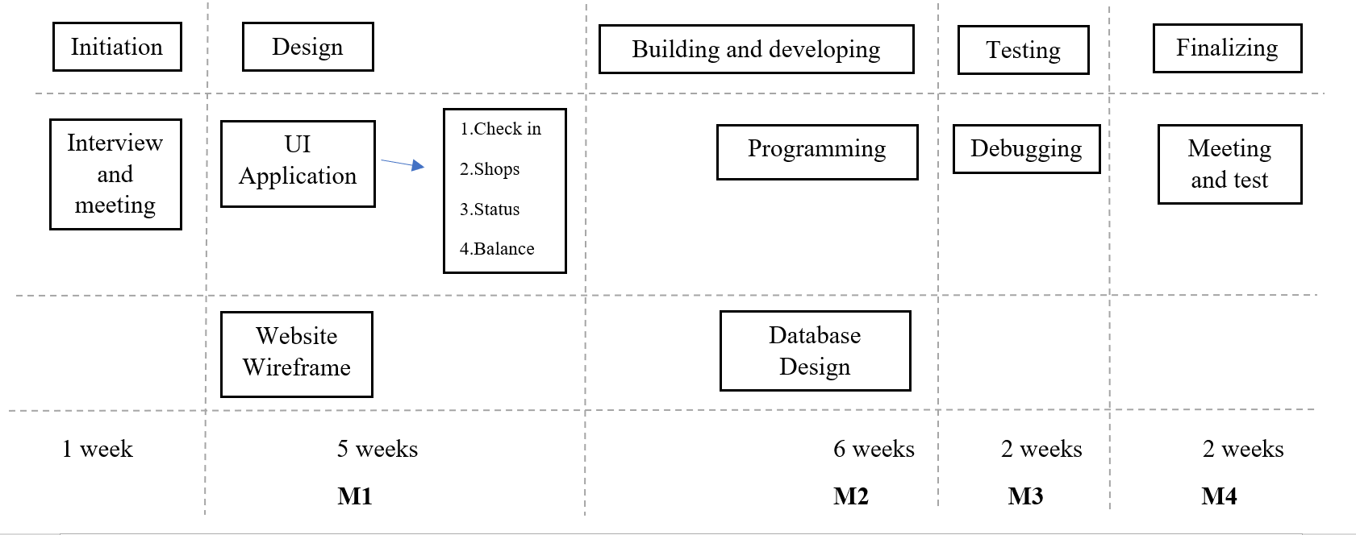

Figure 1 The Main Activities

## **Phase 1: Initiation**

Activity: Interview and meeting

1. Interviews and meetings with the client and mentor
2. Determine the topic of event
3. Logo and name of the company
4. Assignment of positions for each team member
5. Group meetings to clarify the project’s problems and goals
6. Manage a schedule for the meetings

**Estimated duration is one week.**

## **Phase 2: Design**

Activity: Application GUI, website wireframe and database design

* Make non-functional application GUI
  1. Check in and out for Visitors and campings
  2. Shops and loaning stands
  3. Check the overview status of event
  4. Change balance of the visitors based on log files
* Design website wireframe
  1. HTML
  2. CSS
  3. JavaScript
* Database design

Deliverables for milestone **M1** are:

* Non-functional applications GUI
* Website wireframe and static part
* ERD(Entity Relationship Diagram)
* Project plan
* Setup document

**Estimated duration is five weeks.**

## **Phase 3: Building and developing**

Activity: Programming

1. Add functionalities to the applications
2. Add functionalities to the website

Activity: database design

1. Make ERD(Entity Relationship Diagram)
2. Create the database

Deliverables for milestone **M2** are:

* Versions of the applications with functionalities
* Version of the website with functionalities
* Process report

**Estimated duration is six weeks.**

## **Phase 4: Testing**

Activity: Debugging

1. Find possible bugs
2. Fix the bugs

Deliverables for milestone **M3** are:

* Prototype of application
* Updated report regarding the system stability

**Estimated duration is one week**.

## **Phase 5: Finalizing**

Activity:

1. Test the application in working environment
2. Meeting with client and discuss if client is satisfied with the products

Deliverables for milestone **M4** are:

* The finished application and website

**Estimated duration is one week.**